Factory Design Pattern

Factory design pattern is used when we have a super class with multiple sub-classes and based on input, we need to return one of the sub-class. This pattern take out the responsibility of instantiation of a class from client program to the factory class.
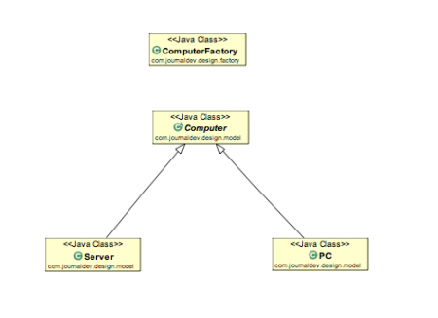

Factory Design Pattern Advantages
- Factory design pattern provides approach to code for interface rather than implementation.
- Factory pattern removes the instantiation of actual implementation classes from client code. Factory pattern makes our code more robust, less coupled and easy to extend. For example, we can easily change PC class implementation because client program is unaware of this.
- Factory pattern provides abstraction between implementation and client classes through inheritance.

Factory Design Pattern Examples in JDK
- java.util.Calendar, ResourceBundle and NumberFormat getInstance() methods uses Factory pattern.
- valueOf() method in wrapper classes like Boolean, Integer etc.

package com.test.design.pattern.factory;

public abstract class Computer {

public abstract String getRam();

public abstract String getHDD();

public abstract String getCPU();

@Override
public String toString() {
return "CPU : " + this.getCPU() + " HDD : " + this.getHDD() + " Ram : " + this.getRam();
}
}

package com.test.design.pattern.factory;

public class Desktop extends Computer {

private String ram;
private String hdd;
private String cpu;

public Desktop( String ram, String hdd, String cpu ) {
super();
this.ram = ram;
this.hdd = hdd;
this.cpu = cpu;
}

@Override
public String getRam() {
return ram;
}

@Override
public String getHDD() {
return hdd;
}

@Override
public String getCPU() {
return cpu;
}

}

package com.test.design.pattern.factory;

public class Laptop extends Computer {

private String ram;
private String hdd;
private String cpu;

public Laptop( String ram, String hdd, String cpu ) {
super();
this.ram = ram;
this.hdd = hdd;
this.cpu = cpu;
}

@Override
public String getRam() {
return ram;
}

@Override
public String getHDD() {
return hdd;
}

@Override
public String getCPU() {
return cpu;
}

}
package com.test.design.pattern.factory;

public class TestFactory {

public static void main(String args[]){

Computer computer = ComputerFactory.getComputer( "Laptop" );

System.err.println(computer.toString());

}

}

